Lesson Focus: Aircraft Design/ Bernoulli’s Principle
Time: Challenge #1
30-45 min. for PowerPoint and Videos, 20-30 min. for plane construction, 20-30 min. for contest and judging Challenge #2
20 minutes for modification and experimentation, 20-30 minutes for contest and judging Challenge #3
20-30 min. for plane construction, 30-45 min. for practice, contest and judgingGuiding Question, Course/Grade Level Expectations, and SPI’s are included for 6th, 7th, and 8th grade Math and Science, Physical Science, Biology, Physics, Algebra 1, Algebra 2, and Geometry. (See the Standards Tab.)
Materials: - PowerPoint “Principles of Flight” (See Tab)
Videos – “Bernoulli” and “Bernoulli 2” (See Tab)
White Wings Paper Airplane Kit (1 per group)
Tacky Glue (1 per group) *dries faster that white glue in kit
Measuring tape or measuring wheel
Stopwatch or timer
4 Hula Hoops for Challenge #3 Testing stationPreparing the lesson:
1. Review PowerPoint, videos, and kit instructions.
2. Divide students into small groups. (4-5 students)
3. Provide each team with an aircraft kit.
4. Decide on a large, open space for judging.

Teaching the Lesson:
- Discuss the physics of aircraft using the attached PowerPoint and video links.
- Provide detailed instructions to students.

Challenge #1
- Decide on 2 design ideas to use from the White Wings Airplane Kit.
- You may not use rubber bands or pennies for design modification.
- Read the instruction 3 or 4 times before you even start.
- Tacky Glue will dry FAST.
- CAREFULLY, punch out pieces, since they will tear.
- Use markers to personalize the planes, so that we can tell them apart.
- Assemble the 2 aircraft according to the instructions.
- Tune your aircraft so that you get the longest time in the air possible and/or the longest distance of flight.
- Direction will not be a factor in this challenge.

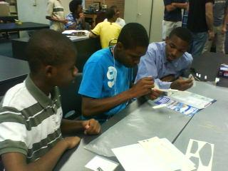

Challenge #2
- Repeat Challenge #1 and consider direction as scoring criteria.
- Points will be deducted for the number of feet the plane lands away from “center,” as shown below.
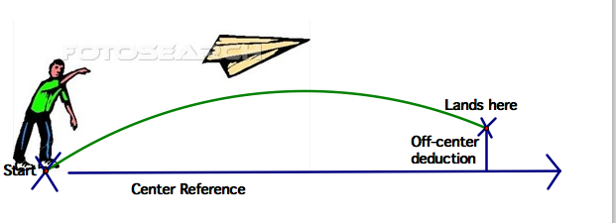
- Trigonometry variation: Calculate the distance by measuring the angle between center reference and airplane path and the linear distance from center, then use Trig functions. (See Tab for Handout.)

Challenge #3-Delivering packages

Describe the following scene. In this challenge, your group will have to make decisions about which aircraft to use, as well as how you will operate a business. Your aircraft will be making deliveries to three different locations (hoops), which are 25ft, 35ft, and 45ft away from your “home airport.”

- You will have 5 minutes to make as many “deliveries” as possible.
- Each delivery to Station #1 will receive $2000, Station #2 will receive $3000, and Station #3 will receive $4,000 per piece.
- The “home airport” and each station will be represented by hoops on the ground, as shown.
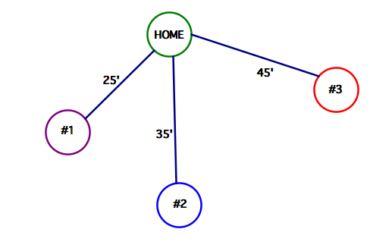
- You will place a group member in each of the hoops and assign one group member outside of the hoops. If you have fewer than five group members, you may rotate members from destination hoops to work outside of the hoops.
- A delivery to a hoop will only be considered complete when your aircraft has reached the destination hoop AND returned to the home hoop.
- Group members may not leave the hoop (both feet) to receive the aircraft.
- If an aircraft should not arrive at the destination hoop, the roving member may re-launch at a refueling penalty.
- There is a $250 refuel charge that will be applied each time the aircraft is re-launched from any area outside of a hoop.
- Aircraft must be re-launched from the point at which it struck the ground.
- The individual in the receiving hoop must have both feet in the hoop when receiving or launching an aircraft.
- If the individual receiving the aircraft fails to catch it, but is able to touch it, it is considered as having been caught.
- The ultimate goal is to make the MOST PROFIT in the 5-minute time limit.
- Experiment with your aircraft and collect data to determine the best way to maximize your profit.

Assessment: Use the following formulas:
Challenge #1
Score = 50*(your flight time/longest flight time from all groups) + 50*(your flight distance/longest flight distance from all groups)
Challenge #2
Score = 50*(your flight time/longest flight time from all groups) + 50*(your flight distance/longest flight distance from all groups) – distance from center
Challenge #3
Score = 2000* # of deliveries to Station 1 + 3000 * # of deliveries to Station 2 + 4000 * # of deliveries to Station 3 – 250*# of re-launches

Closing Activity:
Journal Writing: Have students reflect on their method(s) of problem solving and communicating. How could they have improved their methods, communication, and accuracy?

Extension: Invite Engineering professionals in the field of Aviation to speak to students about college requirements and career opportunities.

