Lesson Plan Subject: Math and Science (9th-12th grades)

Lesson Focus: Chocolate Pavement Time: 45 – 60min

Guiding Question, Course/Grade Level Expectations, and SPI’s are included for 6th, 7th, and 8th grade Math and Science, Physical Science, Biology, Physics, Algebra 1, Algebra 2, and Geometry. (See the Standards Spreadsheet.)

View detailed Tennessee Curriculum Standards: http://www.tennessee.gov/education/curriculum.shtml

Materials: “Pavement” PowerPoint Pavements.pptx
Additional resources available at Society of Women Engineers http://www.swe.org
Heated chocolate (in crock pot) with ladle
Rice Krispies
Oats
Raisins
Wax Paper
48 oz. Plastic Bowls/spoons
Silicone Baking Pans (3”X6”) *Wilton pan with multiple loafs, cut into individuals.
3 Scales to measure grams
Small, clear Sauce cups/with lids, from Sam’s Club
Testing set up: String, Note: This could be an expensive activity. Our cost was approximately $2.50 per student, but we used all “nut-free” products, purchased from Whole Foods, due to food allergies. Look for ways to get these supplies donated by parents, students, or local stores.

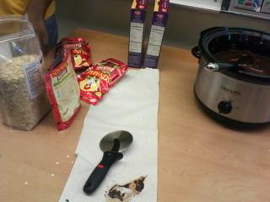

Preparing the lesson:
1. Heat chocolate in crockpot.
2. Divide students into small groups. (4-5 students)
3. Provide access to ingredients, scale, and other supplies.
NOTE: To save time, ingredients can be pre-measured.

Teaching the Lesson:
- Use the “Pavement” PowerPoint to discuss the importance of pavement materials and design choices.
- Discuss, “How can a roadway fail?”
- Discuss “pot holes” and “sink holes.”
- Discuss “coefficient of friction.”
- Discuss “hot mix asphalt.”
- Discuss, “Porous pavement vs. Asphalt pavement.”
- Discuss, “Load distribution through layers.”
- Asphalt is like the glue, rocks provide strength and durability

Starting the activity:

Students are to use the provided ingredients to make “Chocolate Pavement.”
Pavement will be judged based on least mass, least cost, and greatest strength.

- The “cost “ of the ingredients are as follows:
        - $100/ladle of chocolate
        - $75/gram of oats (light weight and added strength)
        - $50/gram of Rice Crispies (light weight)
        - $150/gram of raisins (flexible and light weight)
- Students should work with their teams to decide on a mixture that they believe will accomplish the task for the least amount of money
- Measure and mix the selected ingredients in the bowl. Add the chocolate last.
- Line the 3”x6” Silicone pan with wax paper. Pour the mixture onto the wax paper.
- You determine the thickness.
- Let the sample dry overnight. (May need to refrigerate)

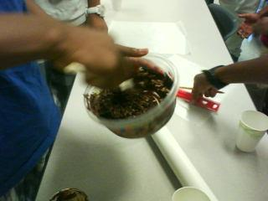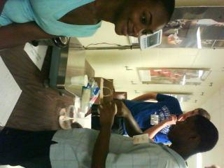

Collect Data from all groups during TRIAL 1.
Testing the samples:

Place Chocolate Pavement between two tables on metal rods, as pictured. Hang weights from center of chocolate until slab fails.

Assessment: Calculate the accuracy for each team using the given formula(s):
100*chocolate + 75*oats + 50*Krispies + 150*Raisins = Total Cost
Total Cost/Mass = Efficiency

(See data chart below)

Award points for 1st place through last place. (Lowest ratio is best.)

Team | Chocolate  (ladle) | Oats (g) | Krispies (g) | Raisins (g) | Mass (g) | Cost/Strength (lowest ratio is best)

Closing Activity:
Journal Writing: Have students reflect on their method(s) of problem solving and communicating. How could they have improved their methods, communication, and accuracy?

Extension: Repeat the activity so that students may test their theories to see if certain changes can create a stronger slap of chocolate asphalt. Add an additional challenge by limiting the amount of chocolate to only 1 ladle.

Retest and compare results from the two trials. Award points based on improvement.

AND/OR

Have students plan and present a technical presentation. (See Technical Presentation Lesson Plan for criteria and grading rubric.)

