GEE EXTRAS
Extra activities to motivate and inspire your students.

1.Forming TEAMS (15 min. to prepare and 15 min. to present)
- Assign students to a group with a “Color” name.
- Each team will develop a team name by adding an adjective and noun to the color name, such as “Beautiful Red Roses.”
- Each team will design a logo and a motto for their “corporation.”
- Each team will make a presentation to the class that will include the following:
  - Each member’s name, school, favorite thing to do
  - Team name
  - Team logo
  - Team motto

2.Forming TEAMS (15 min. to prepare and 15 min. to present)
- Assign students to a group with a “Color” name.
- Each team will develop a team name by adding an animal, such as “Red Bulls.”
- Each team will design a logo and a motto for their “corporation.”
- Each team will make a presentation to the class that will include the following:
  - Each member’s name, school, favorite thing to do
  - Team name
  - Team logo
  - Team motto

Virtual Field Trips and Guest Speakers

http://www.engineeryourlife.org

Demonstrating Design Features of Arches
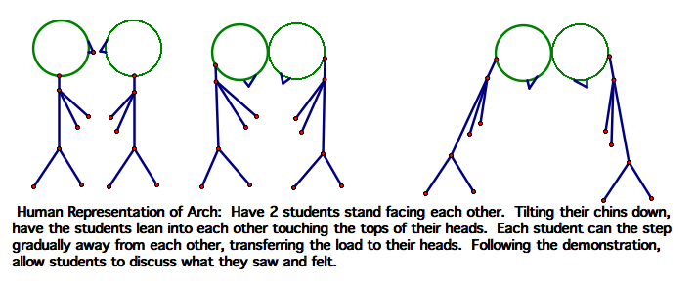

Demonstrating Design Features of Cantilevers (Cranes)
